**Release Plan**

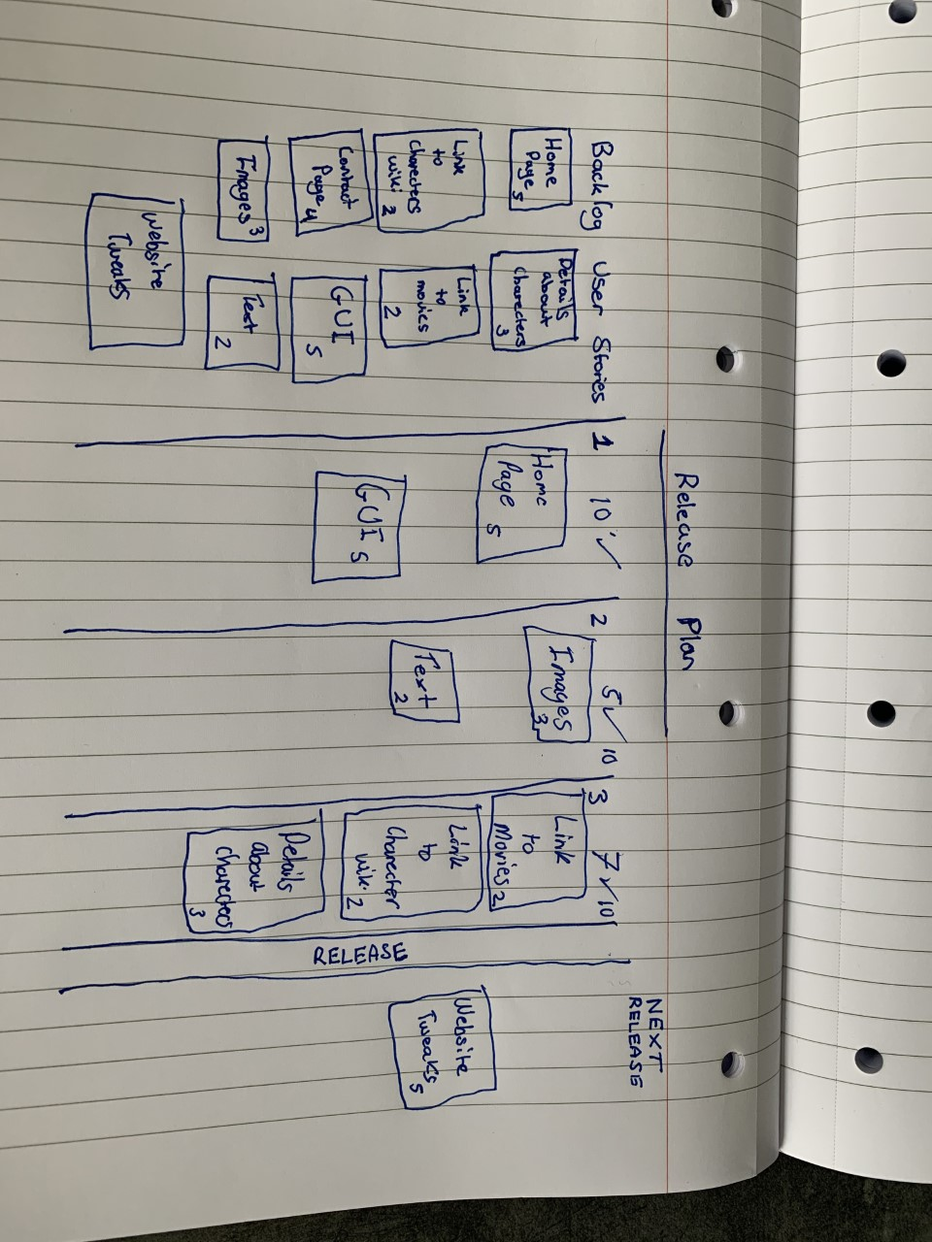

**Team Velocity**

The team velocity was calculated by sitting down together in a meeting room and discussing what we can and can’t do in a space of time. It was all a group effort we used this team velocity to also help us size the user stories.

**Confidence Vote**

In order to make sure everyone was happy with the release plan we needed to take a vote on how we each felt about it. We used a technique called the “fist of five”, where each person would give out a number from 1 to five symbolizing their contentment with the current direction and if anyone’s number was in the low 1-3 the plan would need to be looked over again. To avoid peer pressure, we kept the vote anonymous at first so that everyone could voice their true feelings on the project. It turned out however that everyone was relatively happy with most of us having 4s and 5s. One of us gave out a 3 but their idea about how the plan should be altered was easy to implement.

**Release Plan**

The release plan was put together by us coming up with user stories, then we sized the user stories and broke it down into each release what needs to be done then we voted and which stories we could and couldn’t do in that sprint. After we decided on the stories, we set several points we could do in that stories. We wrote this out on a page took pictures of it.

**Burndown Chart using Jira**

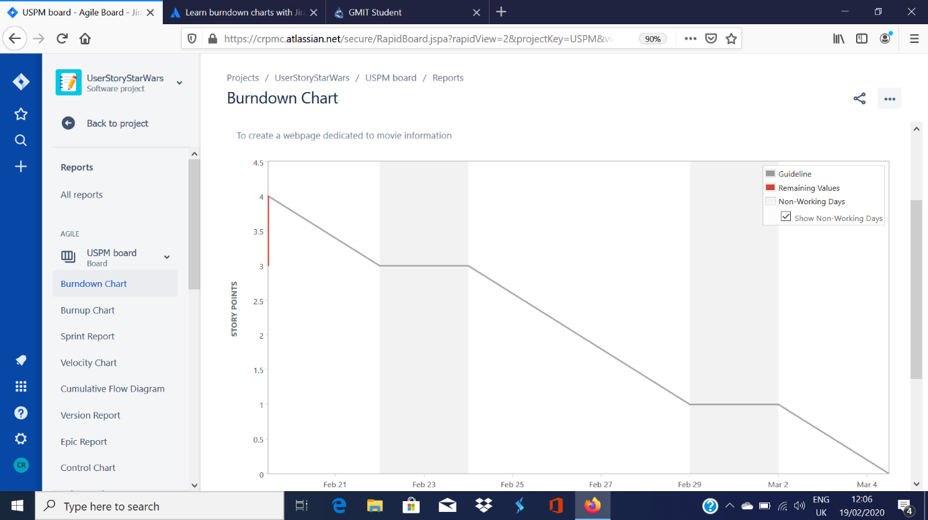

**Description of sprint planning meeting, vote and goals**

We did a stand up and discussed and assed the tasks needed to get done and what goals we had ahead of us. So, we finished doing the release plan and all the charts associated with it then we assigned tasks to complete the user stories and voted and whether we could do these stories.

**Sprint stories tasks, task status and owners**

|  |  |  |
| --- | --- | --- |
| **Stories** | **Tasks** | **Owner** |
| Being able to access the homepage | - Create homepage  - Upload homepage  - Test homepage | - Jakub  - Faustas  - Brett |
| Being able to access the contact page | - Gathering everyones details  - Check details are correct  - Creating the contact page | - Ciarán  - Brett  - Jakub |
| Implementing the GUI design | - Discussing the design  - Creating the GUI | - Everyone  - Jakub / Ciarán |
| Character information section | - Gathering list of characters  - Getting information for the characters  - Uploading character information | - Gavin  - Gavin  - Faustas |

**Scrum Task Board**

